**Guide for setting up the Amazon EC2 Environment.**

1. Select “*Ohio*” from the top-right dropdown list. *Ohio* is the Amazon AWS data center where we want to set up the RDS database. Then, on the top-left, click Services, Compute and finally EC2.

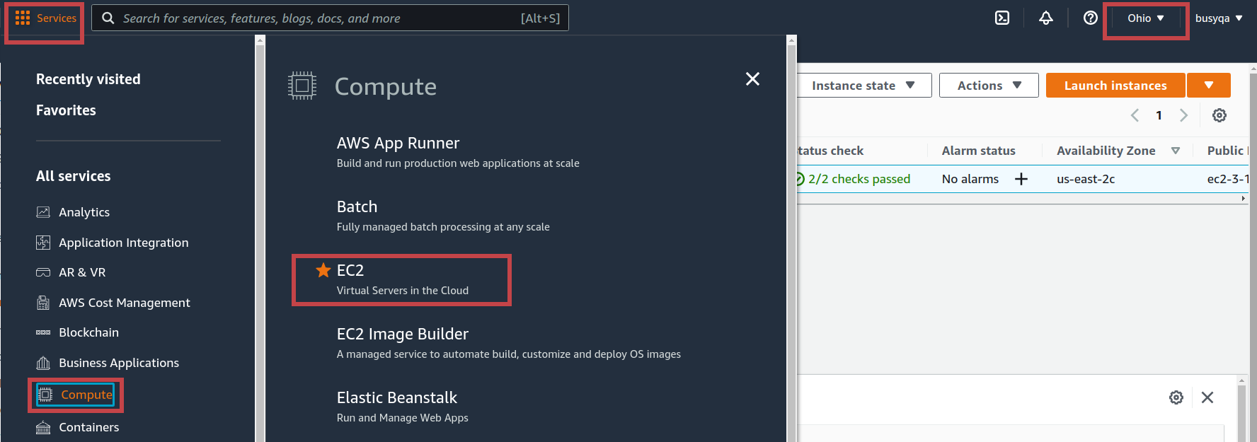

1. Hit the “*Launch Instance*” button to create a new EC2 instance.

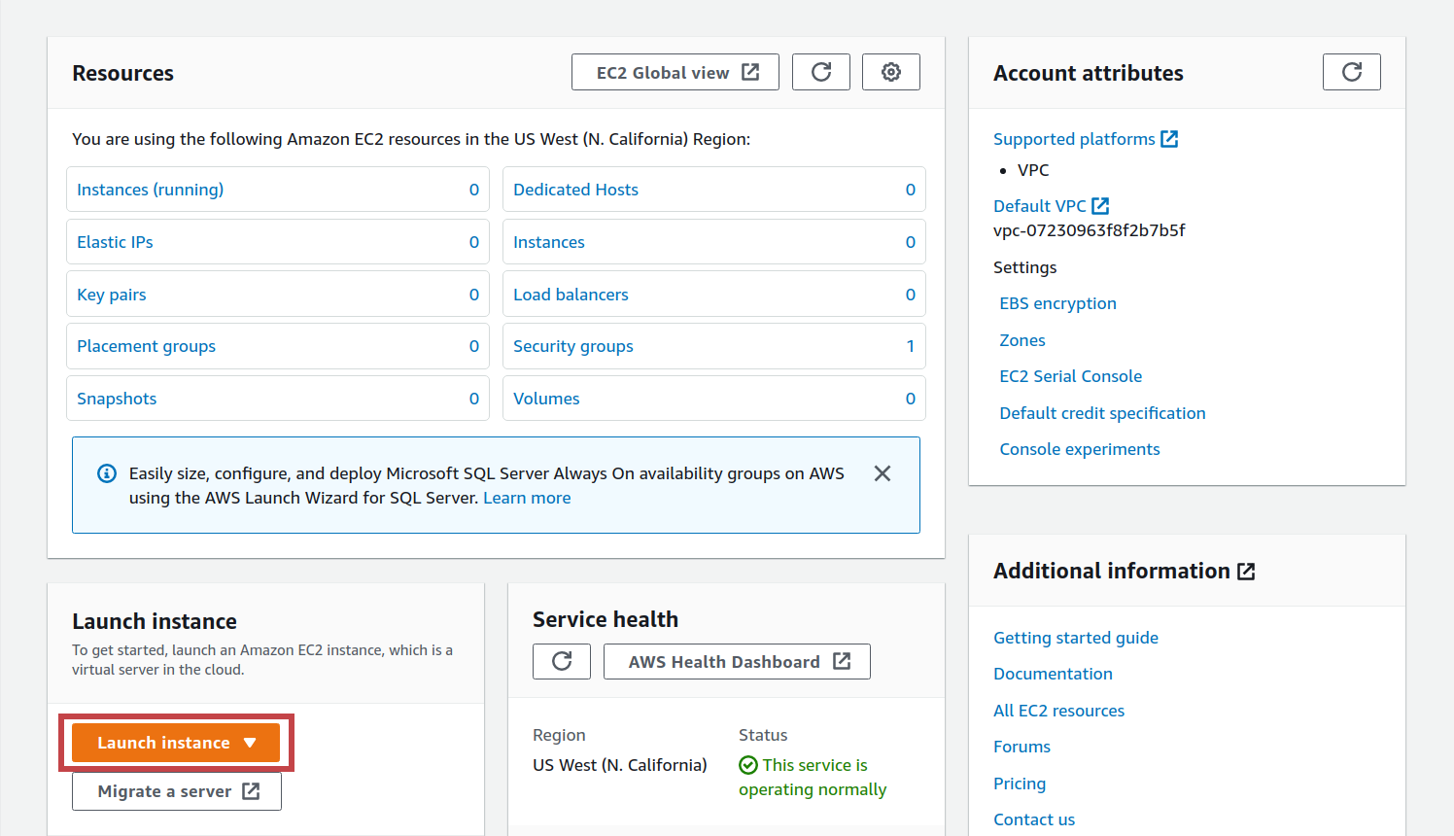

1. Hit the “*Select*” button to create an “Amazon Linux 2 AMI (HVM) - Kernel 5.10, SSD Volume Type” Linux machine instance.
2. 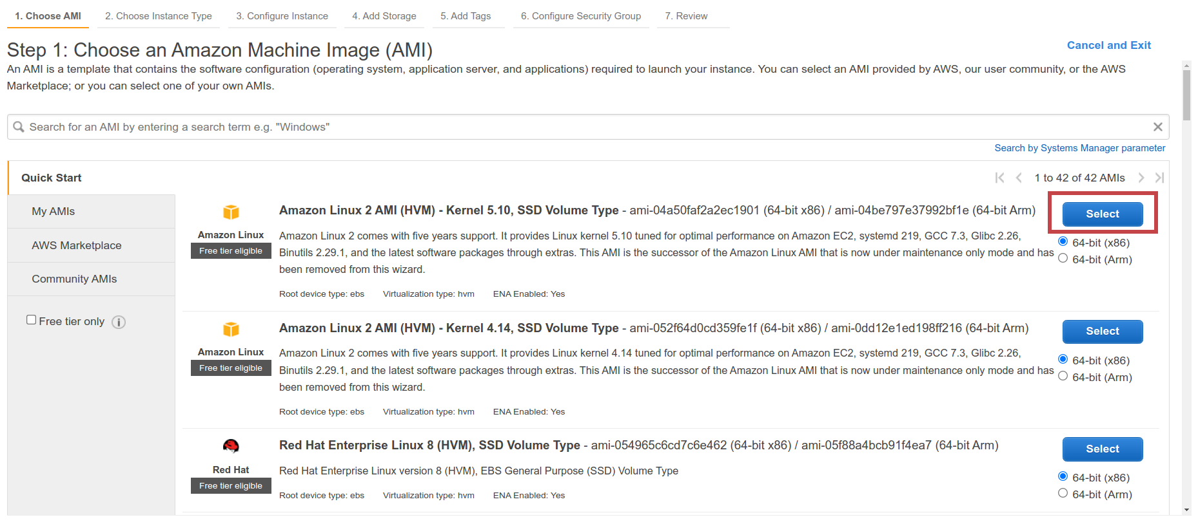We can select the instance type we need to create in the panel below. Keep the default settings and hit the *“Configure Security Group” link from the menu.*

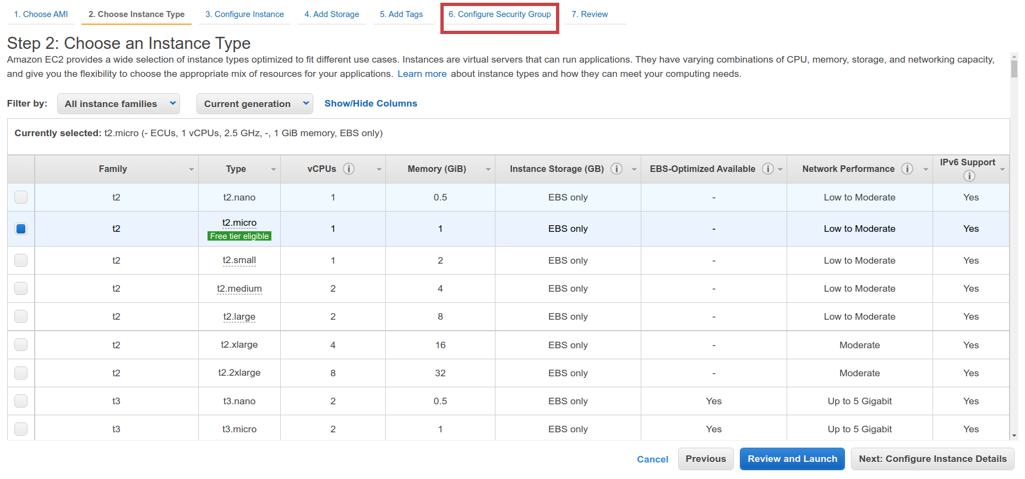

1. Hit the *“Add Rule”* button.

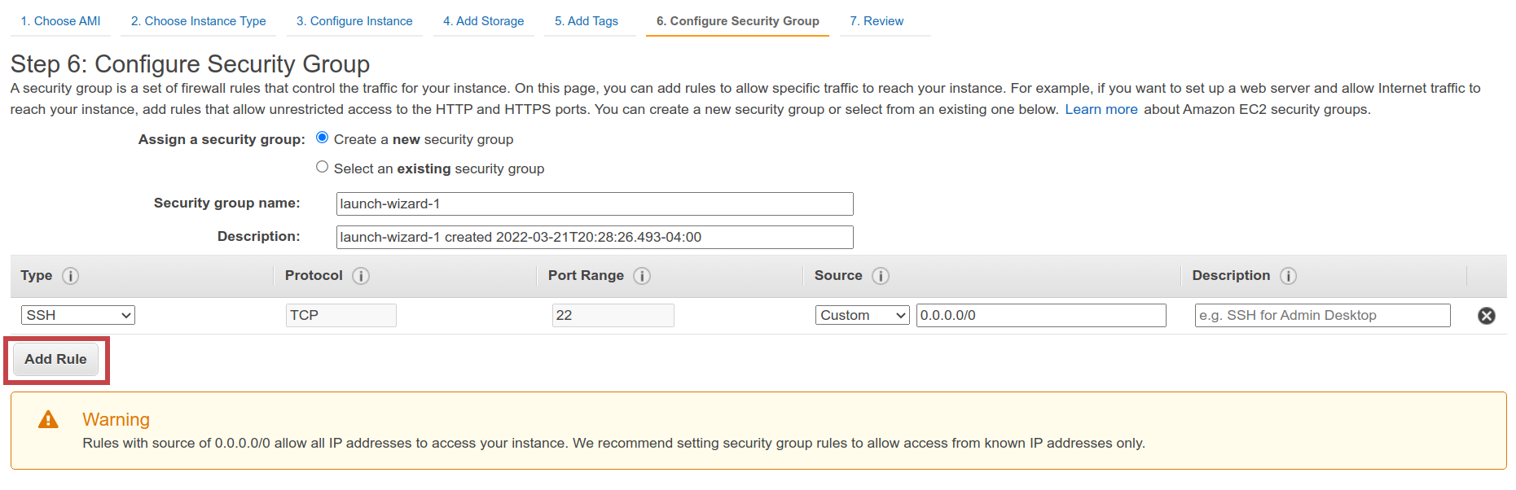

1. Create a couple of new rules with the values indicated below. These rules will allow inbound traffic from the internet on ports 80 and 8080 to 8090. Then hit the “*Review and Launch*” button.

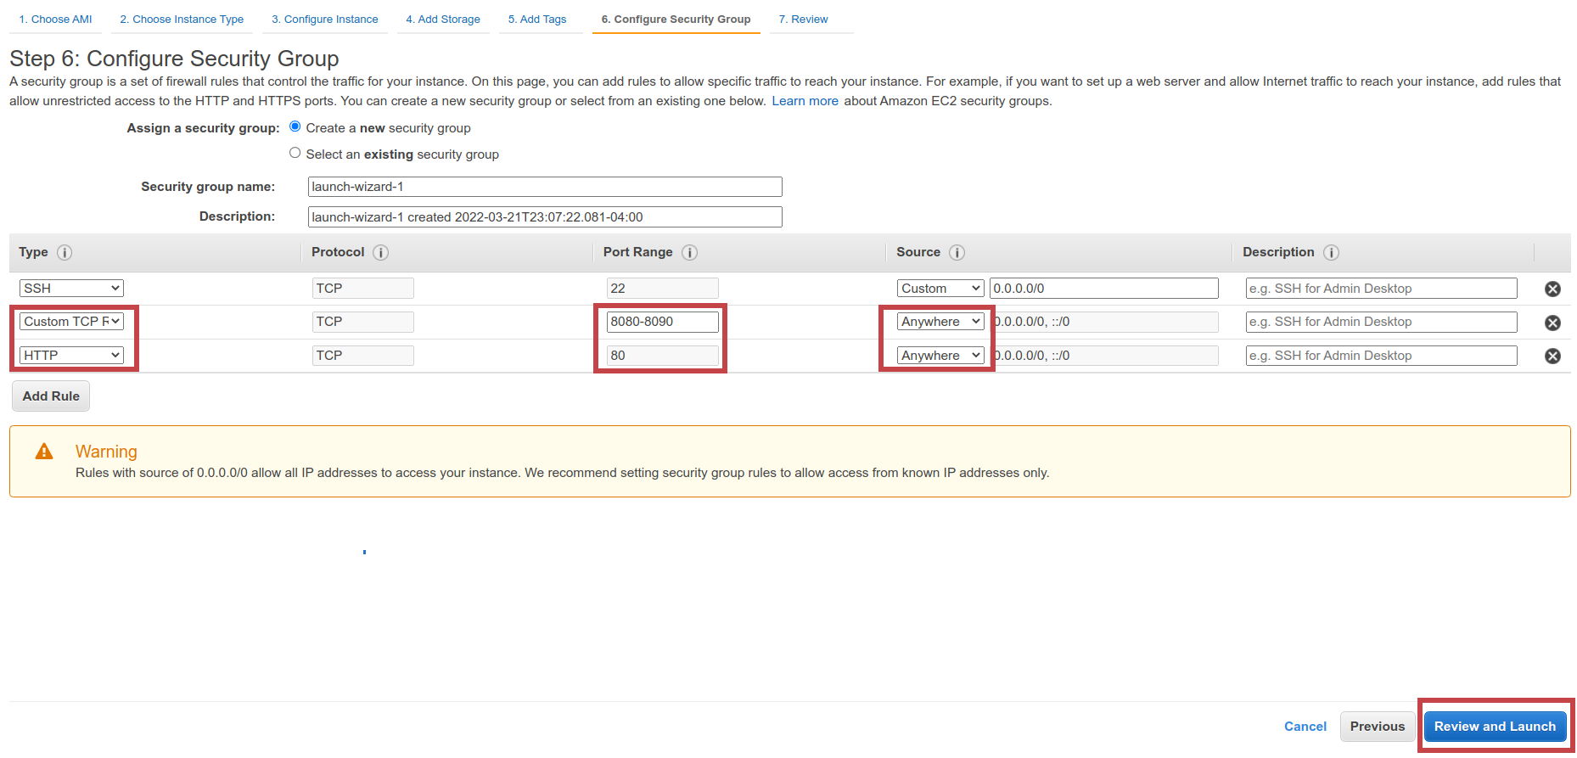

1. Hit the *“Launch”* button.

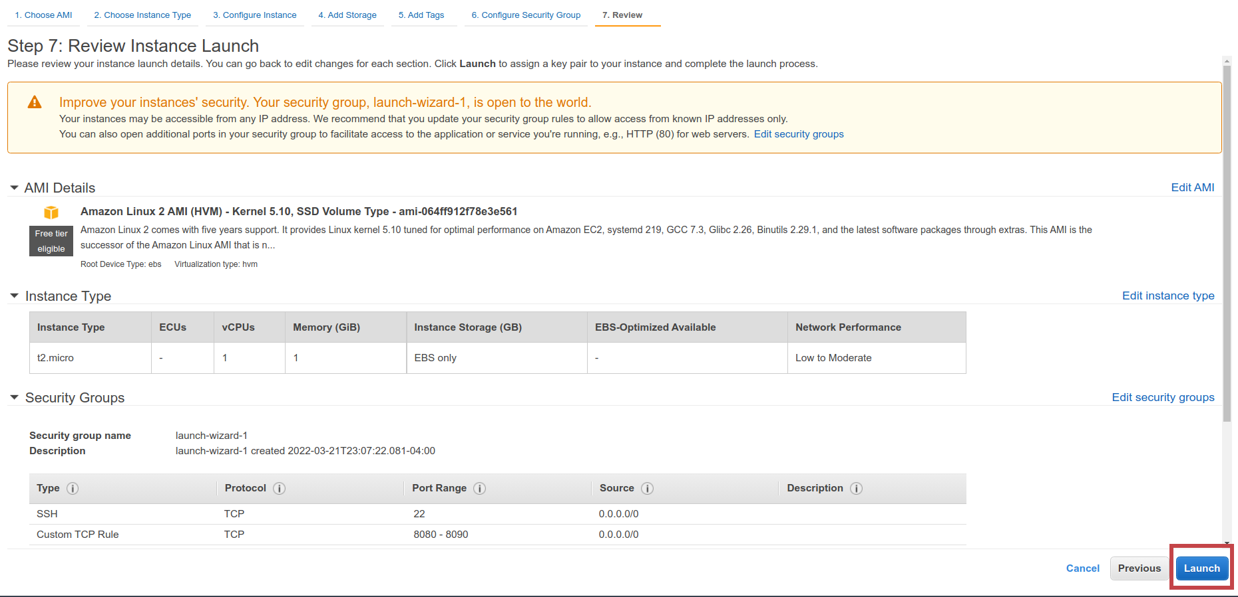

1. Fill out the form below, and then hit the “Download Key Pair” button. Ensure you save the key pair 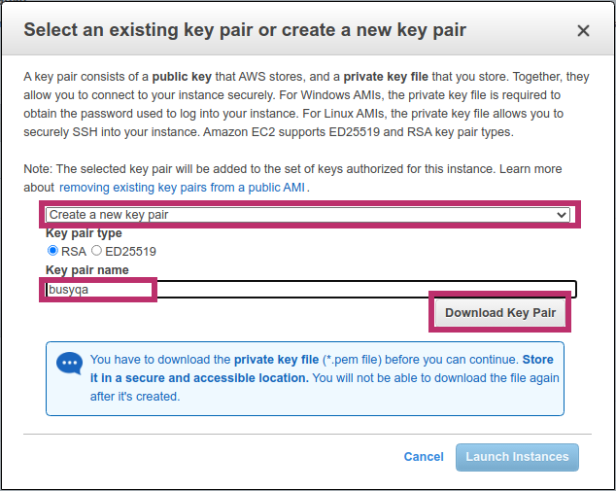file in save place as we will need it later to connect to the EC2 instance.
2. Hit the “*Launch Instances*” button.

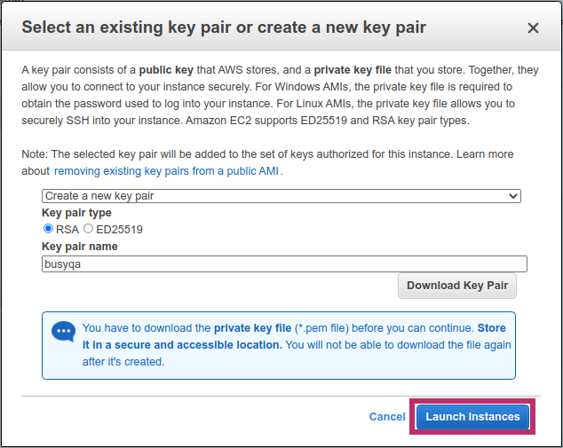

1. Hit the “View Instances” button.

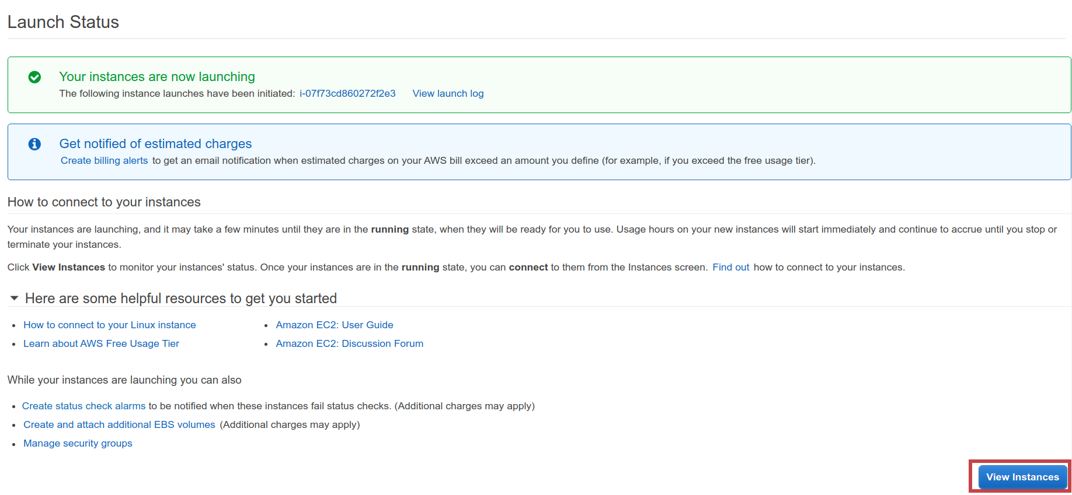

1. After a couple of minutes, your new Instance will be up and running. Check off the instance record and copy the *“public IPv4 DNS”* to your clipboard as you need it later.

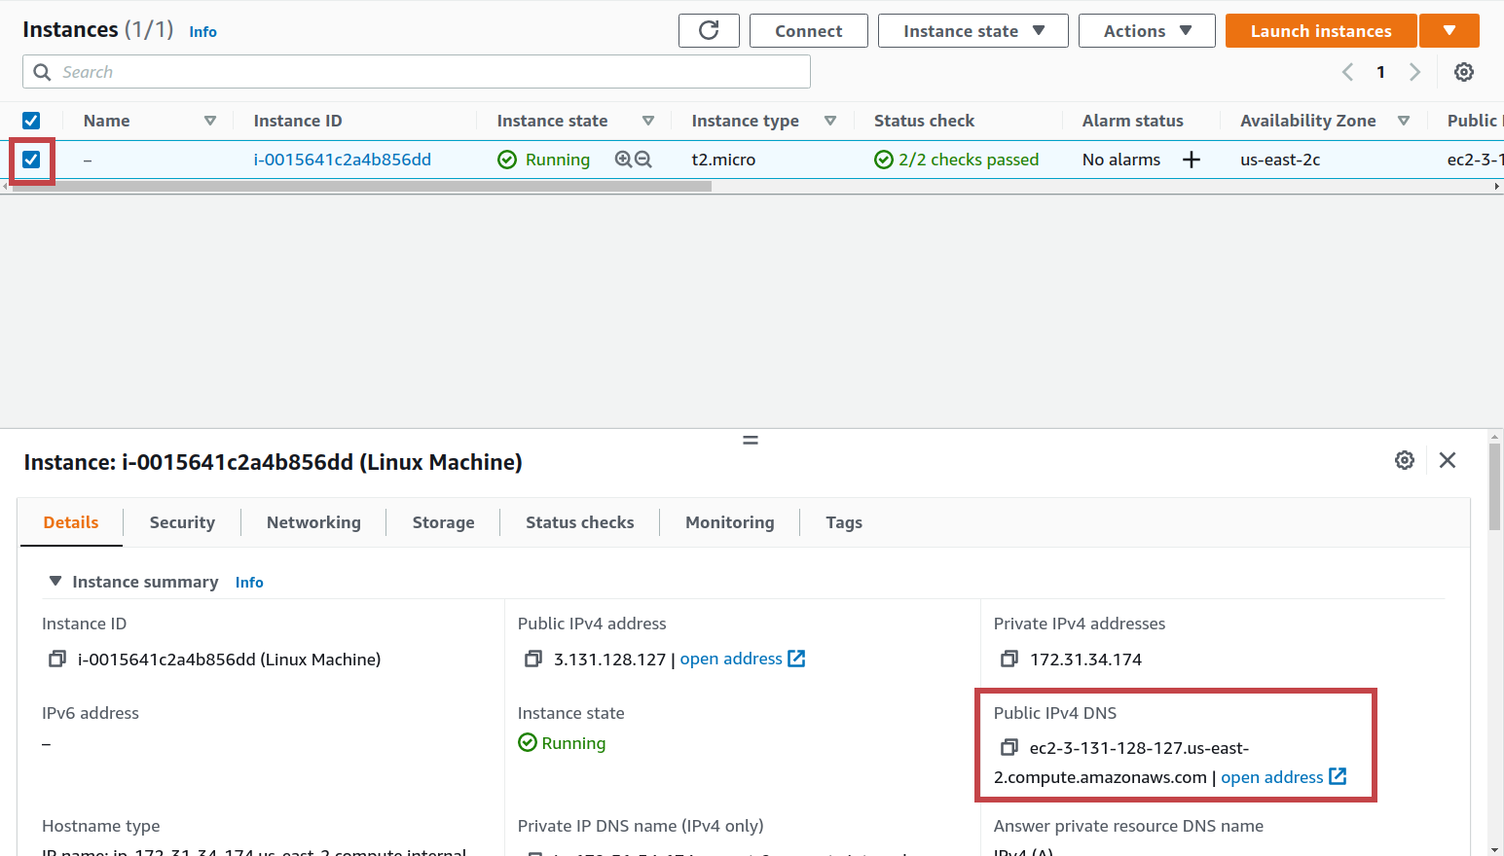

1. *The following steps are for macOS and Linux users. Windows users, please jump to point 16.* Open a terminal in the folder where you saved the “key pair” created in step 7 and run the commands below to connect to your AWS EC2 instance. Replace the square brackets with your information.

$ chmod 400 *[your_pem_key_filename]*

$ ssh -i *[your_pem_key_filename]* ec2-user@*[your_public_IPv4_DNS]*

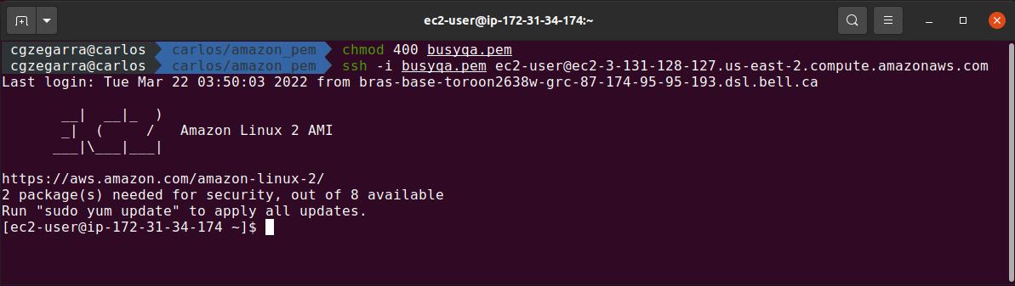

1. Update your instance’s software package with the following command:

*$ sudo yum update -y*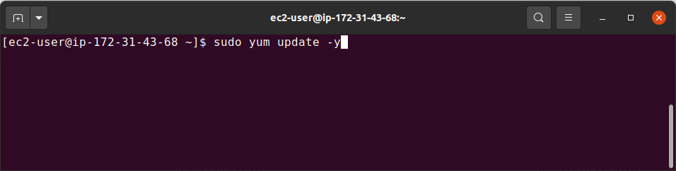

1. Install Java on your AWS EC2 instance. Run:

*$ sudo amazon-linux-extras install java-openjdk11 -y*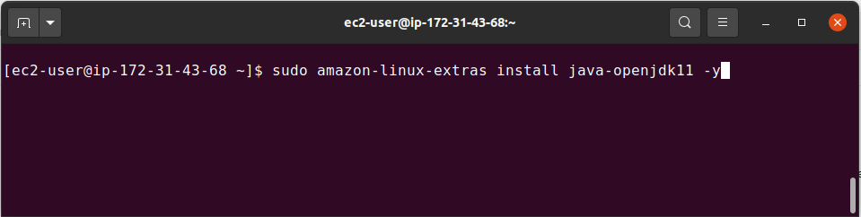

1. Verify Java was installed correctly on your AWS EC2 instance. Run:

*$ java -version*

**Note:** You completed the AWS EC2 instance configuration successfully. If the Java version is displayed correctly and you are good to go. **Congratulations!**

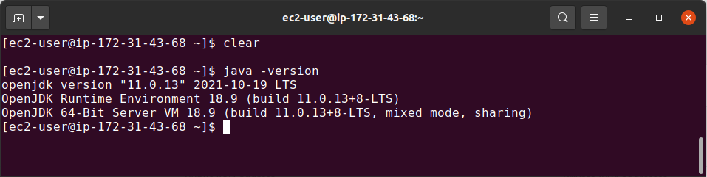

1. The following steps are for Windows users only and explain how to connect to your AWS EC2 instance using PuTTY, a free SSH client for Windows. Follow the link below to install PuTTY on your computer. If you already have an older version of PuTTY installed, we recommend downloading the latest version.

<https://www.chiark.greenend.org.uk/~sgtatham/putty/>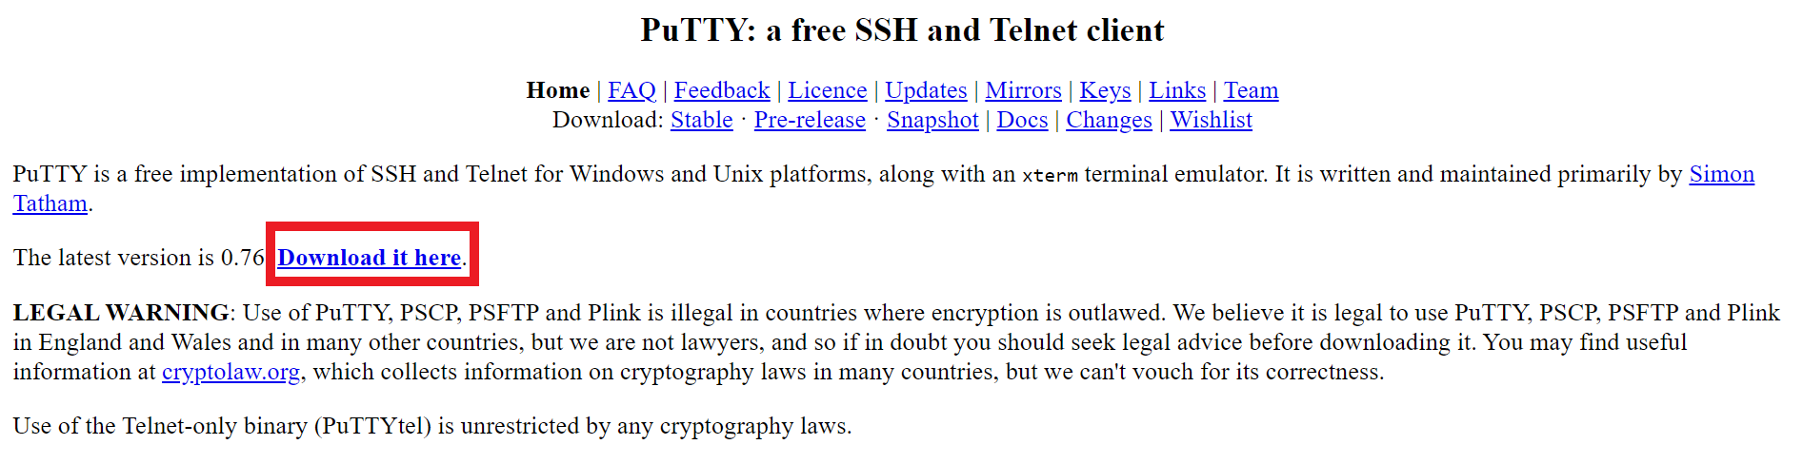

1. Click the link below to download the 64-bit x86 Windows installer.
2. 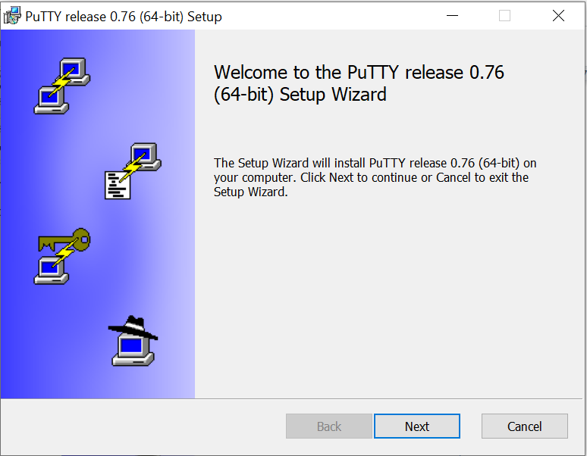Execute the installer and hit the *next* button.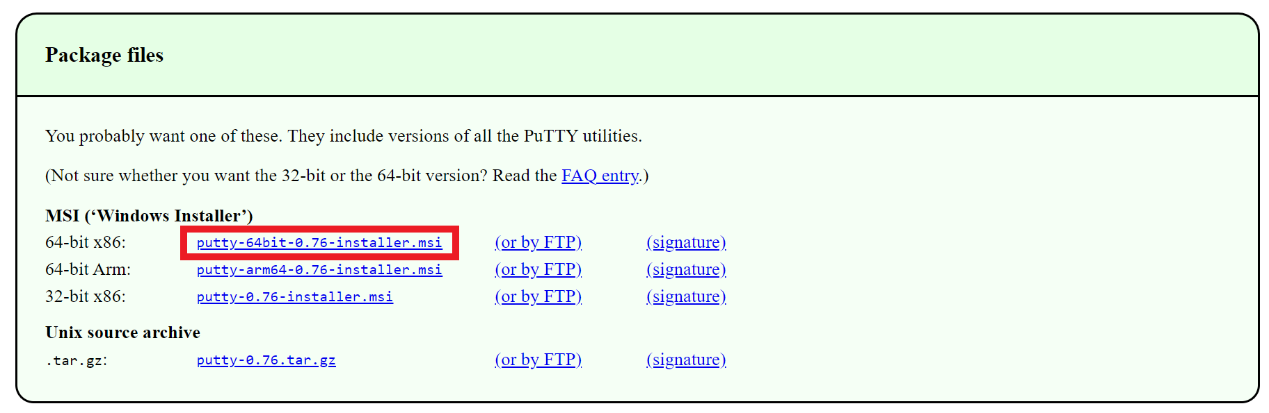
3. Hit the *next* button.

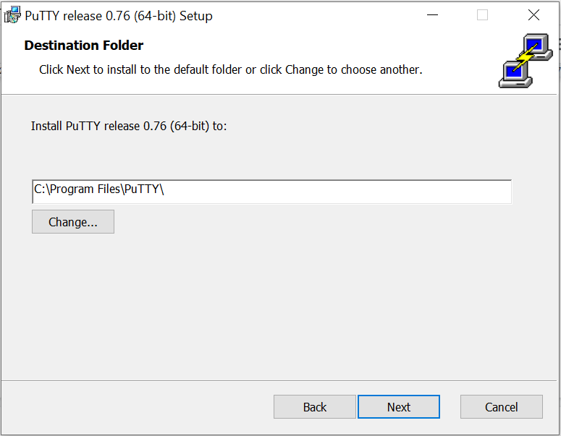

1. Hit the *install* button.

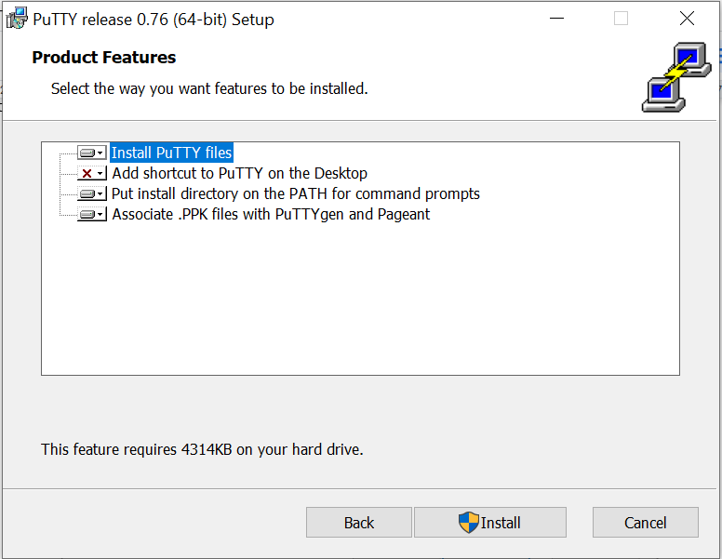

1. Wait for the installation to complete.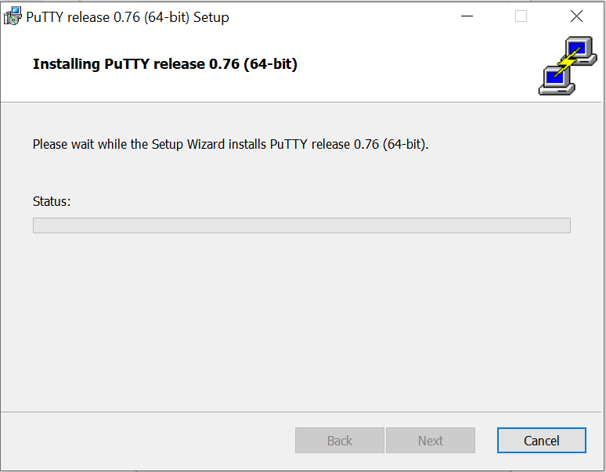
2. Hit the *finish* button.

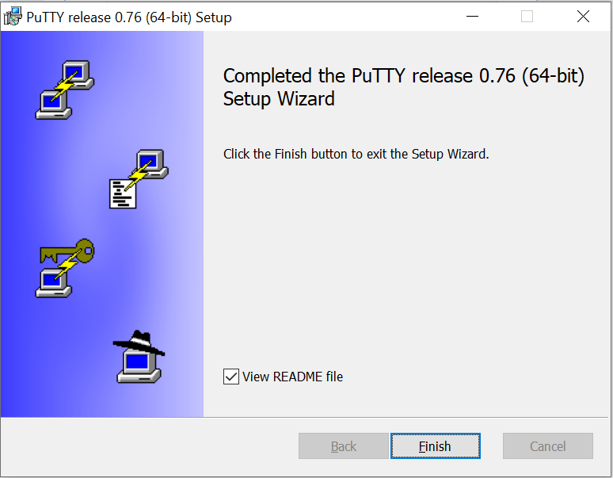

1. Convert your “key pair” (.pem file) created in step 7 into PuTTY format (.ppk file) using PuTTYgen as PuTTY does not natively support the private key format for SSH keys. So from the Start menu, choose All Programs, PuTTY, PuTTYgen.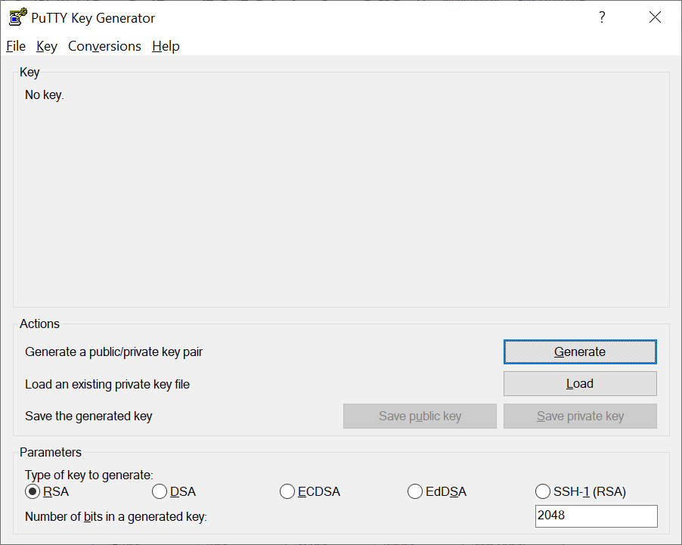
2. Under the type *of key to generate*, choose RSA, then choose Load. By default, PuTTYgen displays only file with the extension .ppk.

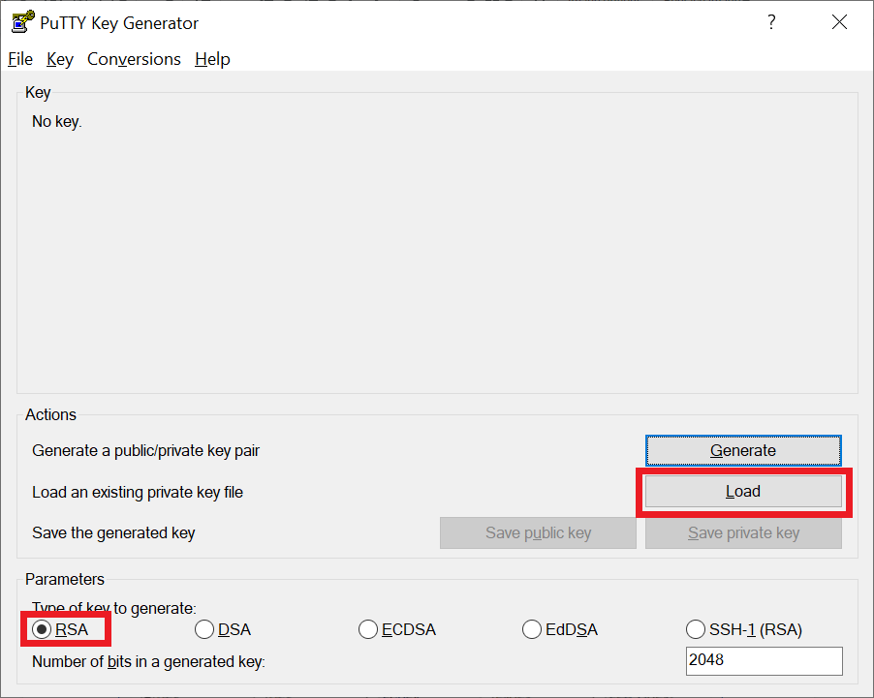

1. To locate your .pem file, choose the option to display files of all types, then choose Open.

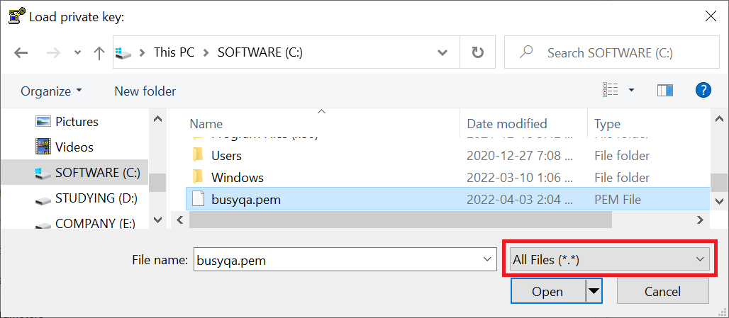

1. PuTTYgen displays a notice that the .pem file was successfully imported. Choose OK.

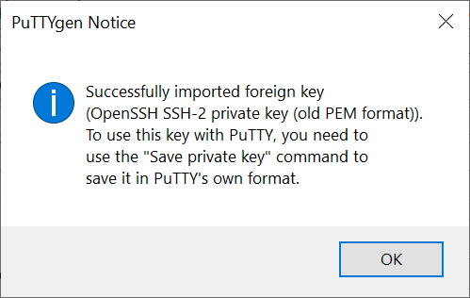

1. To save the key in the format that PuTTY can use, choose Save private key. 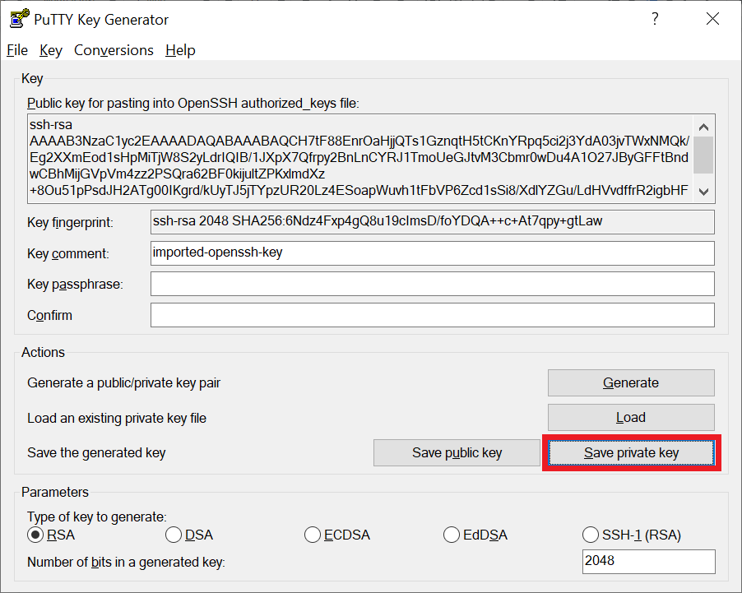
2. 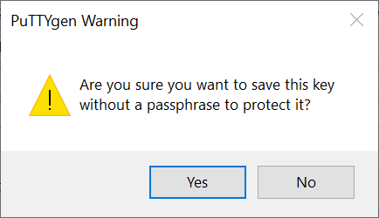PuTTYgen displays a warning about saving the key without a passphrase. Choose Yes.
3. Specify the same name for the key that you used for the key pair and choose Save. PuTTY automatically adds the .ppk file extension.

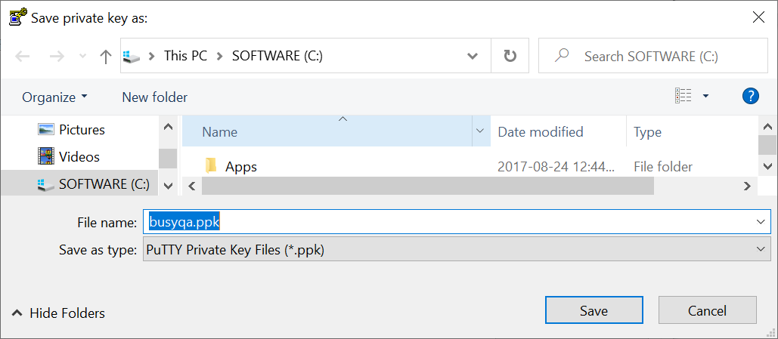

1. Start PuTTY (from the Start menu, choose All Programs, PuTTY, PuTTY).

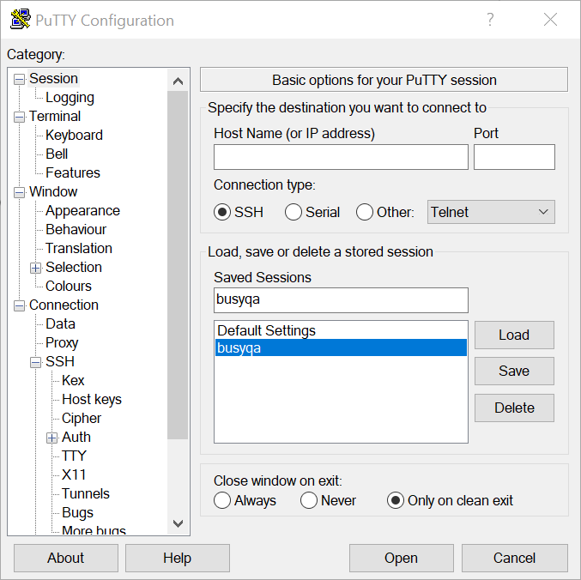

1. In the Category pane, expand Connection, SSH, and then choose Auth. Next, provide the .ppk file that you generated in step 29.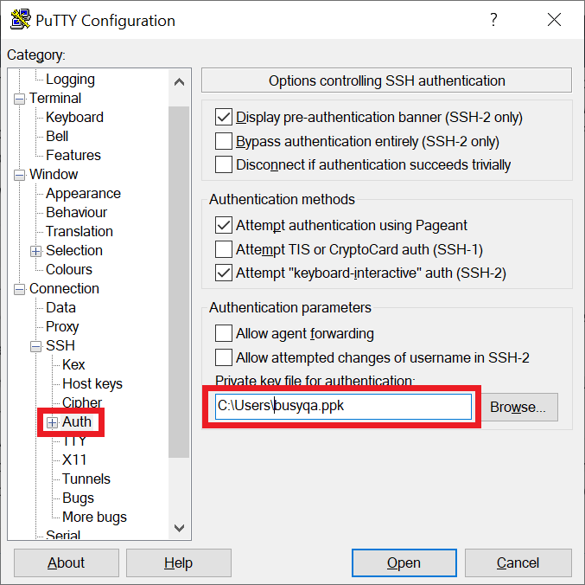
2. In the Category pane, choose Session and complete the following fields. The hostname needs the string “ec2-user@” as a prefix, then hit the *Save* button and finally hit the *Open* button to connect 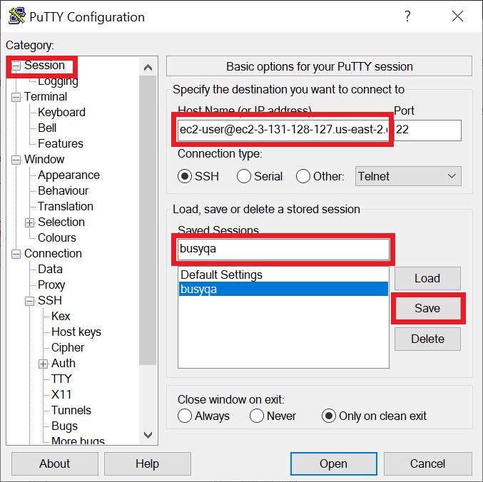to the AWS EC2 instance.
3. Hit the *Accept* button.
4. 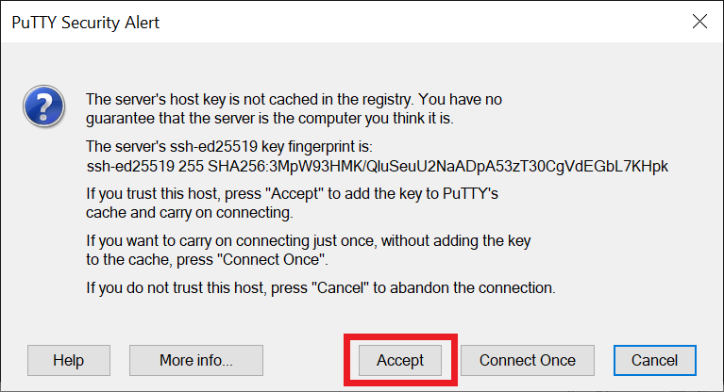Once connected to the AWS EC2 instance,update your EC2 instance’s software package with the following command:

*$ sudo yum update -y*

1. Install Java on your AWS EC2 instance. Run:

*$ sudo amazon-linux-extras install java-openjdk11 -y*

1. Verify Java was installed correctly on your AWS EC2 instance. Run:

*$ java -version*

**Note:** You completed the AWS EC2 instance configuration successfully. If the Java version is displayed correctly and you are good to go. **Congratulations!**



//End